Premier Service Training Series

1099 & Payables Year End Close

When setting up a vendor, you need to make sure they are entered with 1099 information so that the 1099 income will be recorded.
To set up 1099 income for a vendor:
- Open the Vendor Maintenance Card: Purchasing >> Cards >> Vendor
  - Select your vendor from the lookup icon.
  - Click the OPTIONS button.

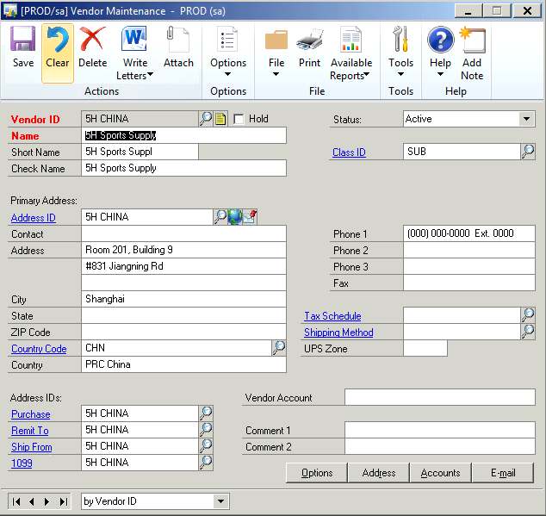

- Note the tax type and the 1099 Box fields on the vendor Matinenance Options Window.

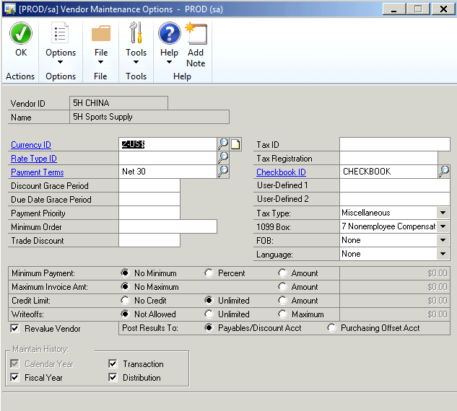

You have the following choices for the Tax Type:
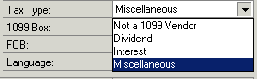
NOTE: Select the vendor's tax type. If you plan to send the vendor a 1099 statement—required by the US Internal Revenue Service for independent contractors and others—at the end of the year, select Miscellaneous, Dividend, or Interest. If you select one of these tax types, you can specify a 1099 amount when entering transactions and you can print 1099 statements for the vendor at the end of the year.

You have the following choices for the 1099 Box:

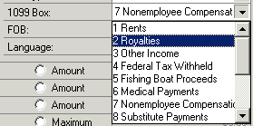
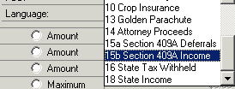

NOTE: If you print a 1099 statement for this vendor, enter the 1099 statement box number where you are most likely to report amounts. The box number you enter is used as a default when entering transactions for the selected vendor.

- When you are done selecting your 1099 options, click OK to close the window.

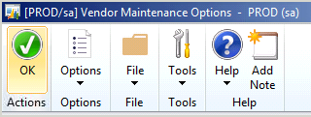

- Save then close your vendor file.

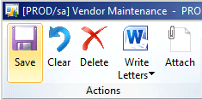

WHAT DID THE 1099 SETTINGS DO FOR THE VENDOR??

Look at the Payables Transaction Entry Window. Note that when you are entering an amount in the purchases field for a 1099 vendor that the amount auto-populates the 1099 amount field.
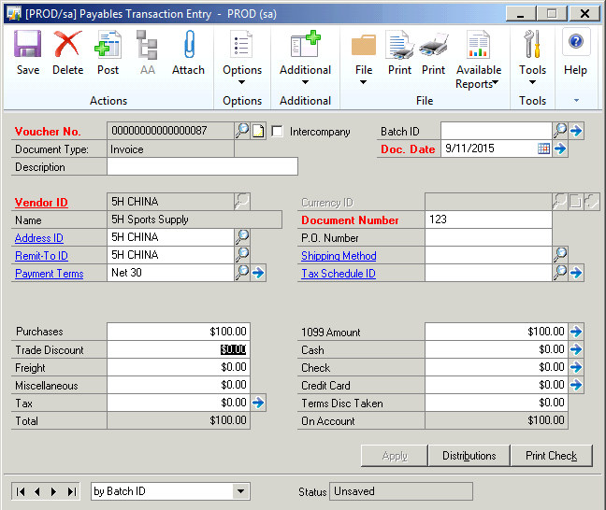

When the blue arrow is selected next to the 1099 amount field a pop up window will open displaying the Tax Type and the 1099 Box number associated with the 1099 amount.

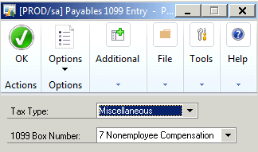
Close your A/P Year End
Make sure that you post all transactions for the year you intend to close before closing the year. And, be sure to back up your data before closing;
- Begin your A/P close: Microsoft Dynamics GP >> Tools >> Routines >> Purchasing >> Year End Close
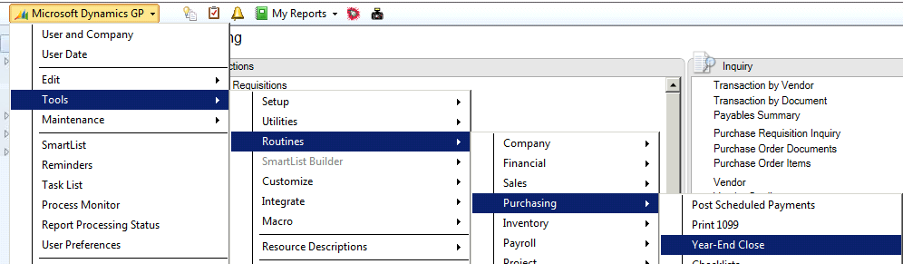
Or from your purchasing home page:

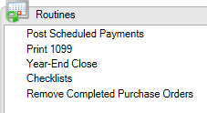
**What this does to data
- Transfers YTD Balances into Last Year Balances for the Vendor
- Fiscal close = Transfers Payables Data
- Calendar close = Transfers 1099 Data
NOTE: If your fiscal year coincides with the calendar year, you can close both at the same time by choosing ALL.

**If you pay a vendor in the new year and post to the new year prior to closing Payables, then the Vendor Yearly Summary amounts since last close will be incorrect

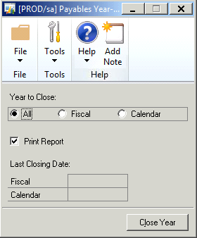
Click “Close Year”
Make sure a check march appears in the Print Report box.

1099 Edit Report
- Print Edit Report for 1099: Routines >> Purchasing >> Print 1099

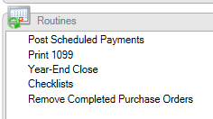

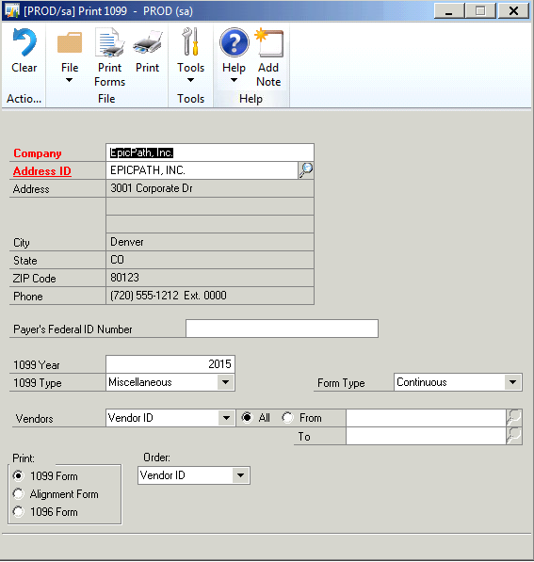

- Select your 1099 Type and Form Type.

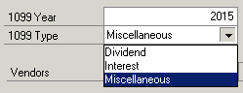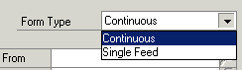

- Click the PRINTER ICON to print an edit list for review. **Do not select Print Forms!!
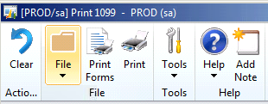
- Review your edit list for any corrections needed and correctness.

How to compare your 1099 data to confirm it is correct:
There are a few different ways that you can review your 1099 data to determine that it is correct.
      - RUN A SMARTLIST:
        - From your Microsoft Dynamics GP Menu, open the smartlist.
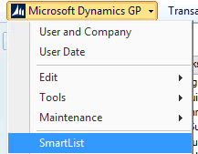

        - Open the Purchasing folder and navigate to Vendors. Open the 1099 Vendors* smartlist report.
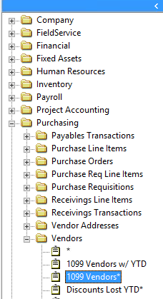

        - Go into “Columns”, and then “add”.
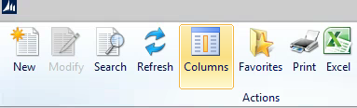
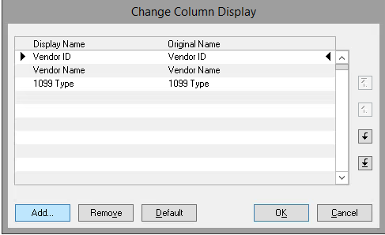

        - Select the “1099 Amount YTD” field and click “OK”. Then click OK again. You will see the field in your new report.
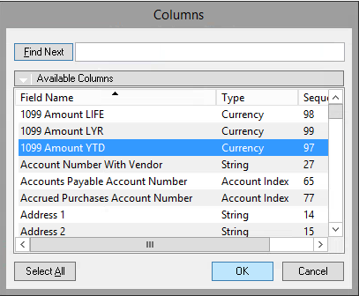
        - You can now review the Smartlist report with the 1099 Edit report to make sure that your vendor figures are the same.
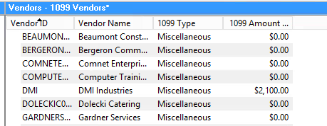

      - REVIEW 1099 TRANSACTION AMOUNTS:
        - From the Purchasing Module, open the Edit 1099 Transactions window: Purchasing >> Transactions >> Edit 1099 Transactions.
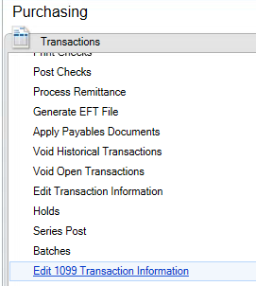
      - Enter a vendor from your 1099 Edit Listing and pull up their history. You can add together the current year transactions showing in the listing and compare them to the 1099 Edit Listing.
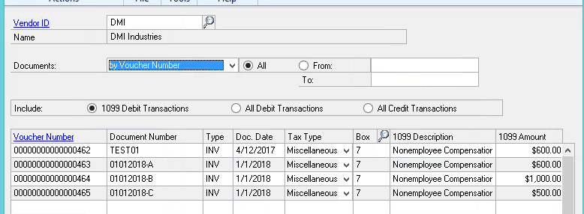
**Troubleshooting Tip:
If you find your totals are not matching, run a smartlist of vendor transactions and download to excel. Run a summary total of the payment transactions and check the posting dates. Make sure that your year end has been closed for Purchasing module. If you have any problems reconciling, please call the support desk for further assistance.

What if I need to Correct a 1099?
If you find you have to correct a vendor’s 1099 information, you can do so from several different places within GP.

REVIEW THE 1099 DETAIL FOR YOUR VENDOR:

- Open the 1099 Detail window: Purchasing >> Cards >> 1099 Details

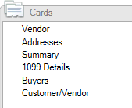

- Select the vendor you need to correct. In this window, you can Change your Tax Type and review. You can also scroll through by month to review each month, or select year for the whole year’s totals. **If you need to make changes to your amount, you must be in display by MONTH!

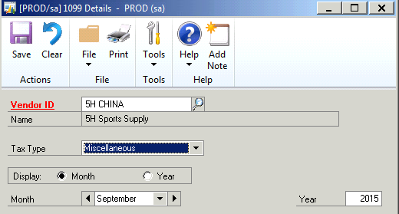

- Make changes to your amount direct in the window. **NOTE: You can only make manual changes in this window if you are in the “month” display. You cannot make changes from the “year” display option.

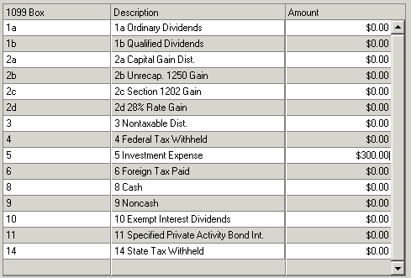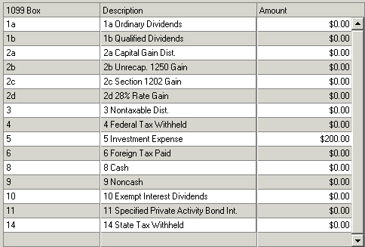

- Save your changes.

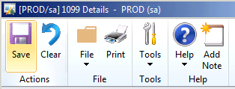

- Double check your 1099 Edit listing for this vendor by running an edit list.

MASS UPDATE FOR A VENDOR:

You may find that you need to change a vendor’s tax type from a non-1099 vendor to a 1099 vendor. This option will allow you to change the vendor card along with all transactions posted for the vendor. **NOTE: this option will change ALL transactions for the vendor.

- Open the “Update 1099 Information” window from GP Utilities in Purchasing. Purchasing >> Utilities >> Update 1099 Information.

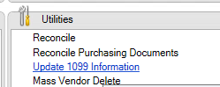

- This window will allow you to update the Vendor card only, specific vouchers or both the vendor card and all transactions.

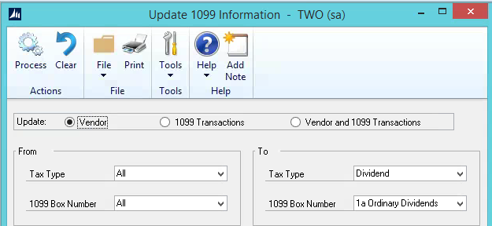

  - VENDOR: This option will only update the vendor card. NOTE: Updating the vendor card only will not update prior transactions that have already been posted. The change will only take effect on transactions posted going forward from the date of change.
  - 1099 TRANSACTIONS: This option will allow you to select a specific voucher number and change the tax type of the transaction. You can enter a range of vouchers or a single voucher. NOTE: If you enter a range, all transactions in that range will be updated. The range must be in succession order.
  - VENDOR AND 1099 TRANSACTIONS: This option will update the vendor card and change all prior transactions that have been posted for the vendor. NOTE: This option will only update ALL transactions for the vendor. You cannot choose the transactions from this option – it must be ALL.

- Enter your “from” and “to” options for the tax type. GP will default to “ALL”.

- Select your vendor and “insert”. When ready, select “PROCESS”.

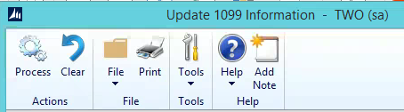

- GP will produce a report showing you each transaction, the prior tax type and the new tax type.

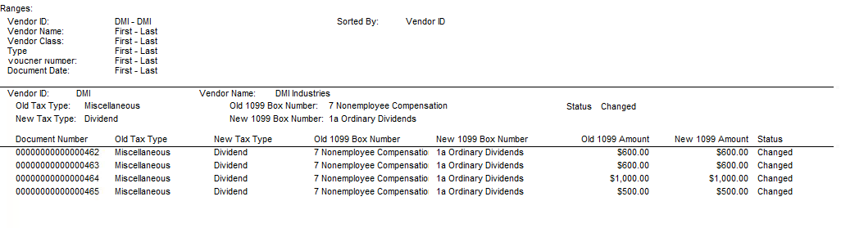

CHANGE TRANSACTION INDIVIDUALLY:

You can also change just one transaction for a vendor if that is necessary. As seen above, this can be done through the “Update 1099 Information” window, or through the “Edit 1099 Transaction Information” window.

- To change from the Edit 1099 Transaction Information window, open the window from Purchasing >> Transactions >> Edit 1099 Transaction Information.

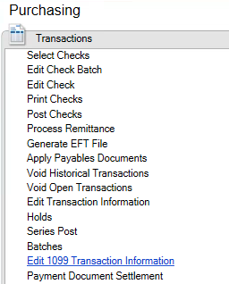

- Select your vendor and hit tab to pull up the transaction information. **NOTE: This window will pull up all transactions for the vendor, including prior years.

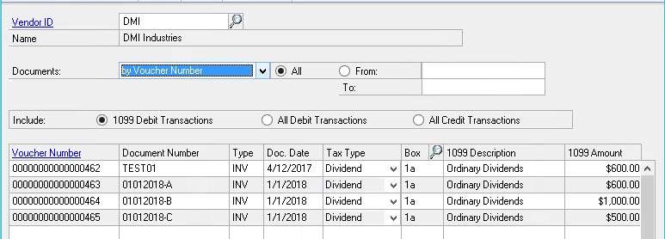

- Select the Voucher number, or numbers that you need to change. (All, or select a range)

- From the “Tax Type” column drop down, you can change a single voucher or several at the same time. Mark the tax type you need to change the vendor transactions to and then click “PROCESS”.

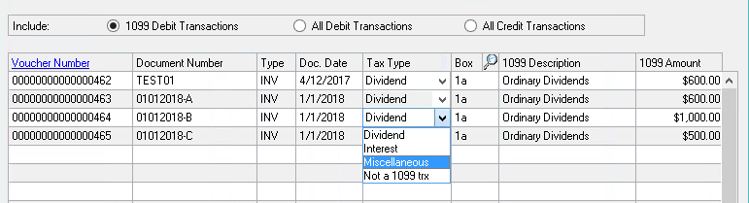

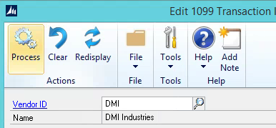

- GP will provide a report to show the changes made. Print and save for your records.

Print your 1099’s
**The IRS form is standard for everyone. You can use any standard 1099 form that is compatible with your printer.

1) Print your 1099’s: Routines >> Print 1099

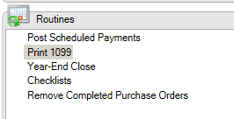

- Select your company Address, enter the Payer’s Federal ID Number, verify the year you are printing and the type.
  - Select your company address ID and verify.
  - Enter the Payer’s Federial ID Number.
  - Verify the year you are printing for and the type of 1099 forms. Select the form type.
  - Make sure you mark 1099 Form in the Print box. You can also print an alignment form or 1096 form.

NOTE: GP will allow you to print all vendors (recommended) or a range of vendors. Multiple copies can be printed if needed. 1099’s can be printed for only one tax type per run

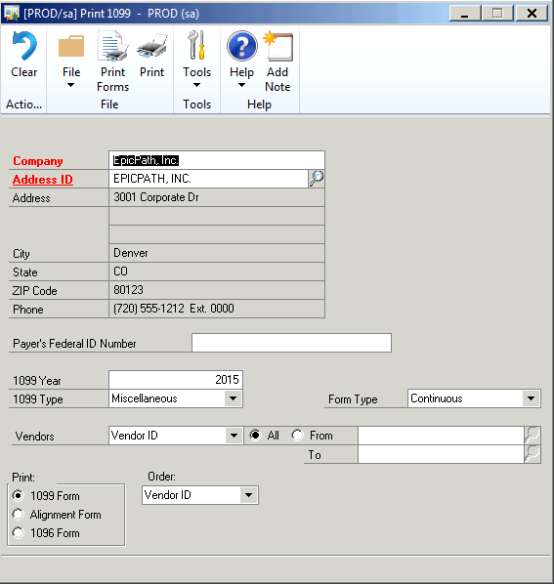

- Click “Print Forms” to print your 1099’s.

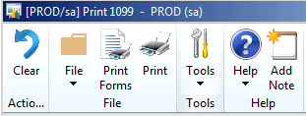

TROUBLESHOOTING TIP: GP will allow you to reprint your 1099’s as many times as you need to. Because GP does not have electronic filing, it will print each 1099 in succession. You will need to print a second set for duplicates. You may reprint a range of vendors or a specific vendor. There is no limit to reprinting your 1099’s!

What if I need to correct alignment for my 1099’s?
CHECK YOUR GP VERSION:
You can find what version of GP you have in several places.
HELP WINDOW:
- Check the version through the “About Microsoft Dynamics GP” option from the help window. Click the “?” icon in the upper right corner of your screen, and then select “About Microsoft Dynamics GP”.
- View your version in the window:
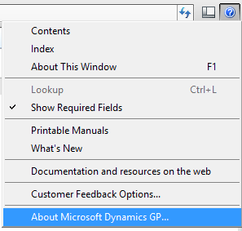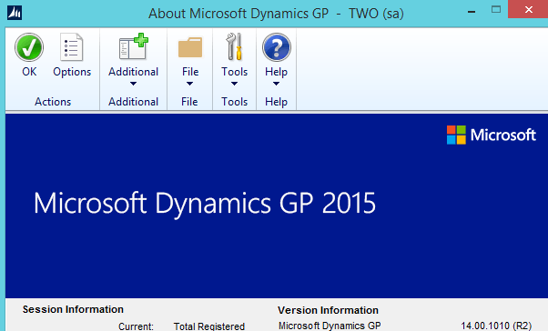

LOG IN WINDOW:
- Launch GP.
- On the login in window, GP should reflect your version in the header:
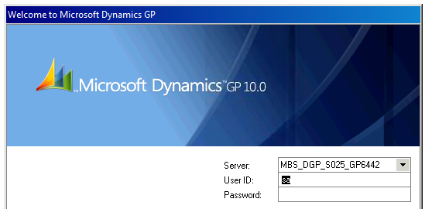

FROM YOUR SMB PORTAL APPS MENU:
- Look at the GP icon in your portal hosted applications menu.
- Most users have the version showing under the icon name:
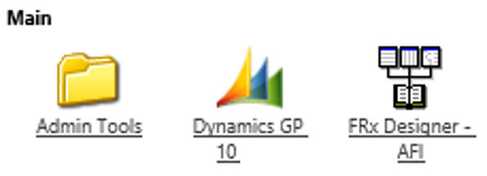

FOR GP VERSIONS OLDER THAN GP2013 (09, 10, 2010):
If you are on a GP version that is older than GP2013, and you have an alignment issue, please contact the support desk. The only way to fix the alignment in older versions of GP is to update the form in Report Writer.

FOR GP VERSIONS 2013 AND NEWER:
If you need to fix alignment of your 1099 forms, you can do this through the print options window.
- When ready to print, select to print your 1099’s:

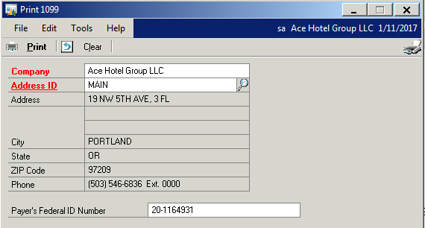

- Select the “PRINTER” option in the print window.

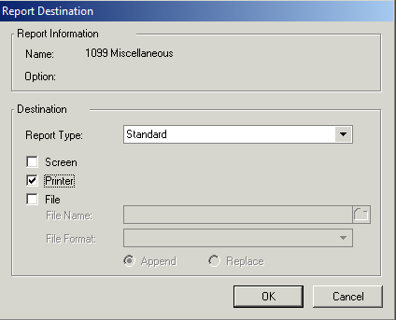

- When the printer options window opens, select the “Preprinted Form Options” tab.

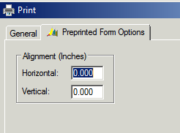

- You can adjust your alignment in this window and then click apply.

- Test your print alignment and continue to adjust if necessary.

